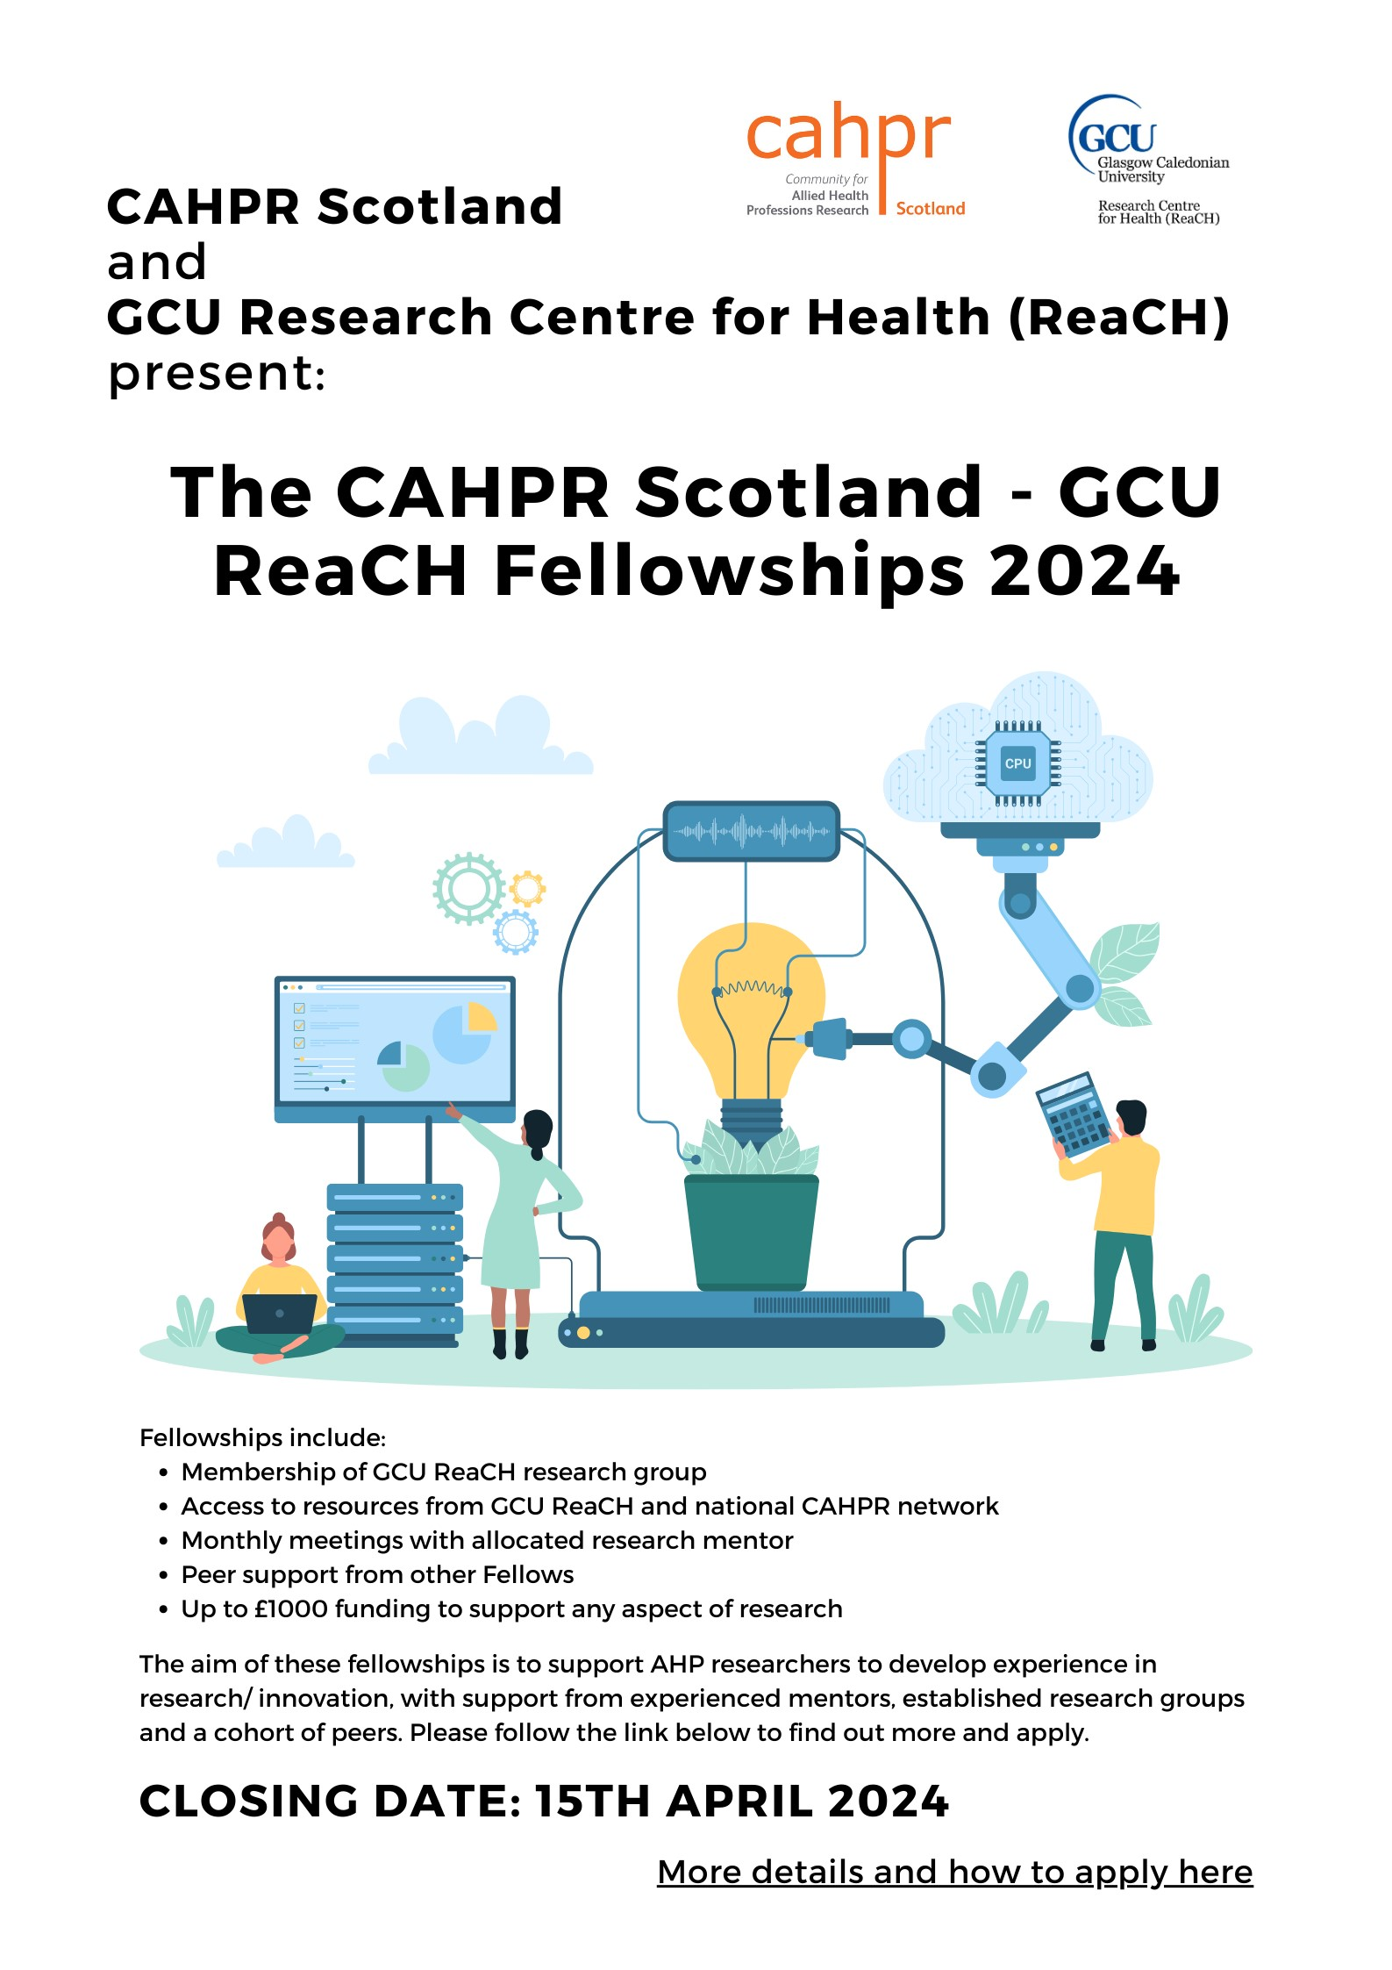

CAHPR Scotland - GCU ReaCH Fellowships 2024/25

CAHPR (the Community for Allied Health Professions Research) Scotland is delighted to partner with the Research Centre for Health (ReaCH) at Glasgow Caledonian University to deliver the CAHPR Scotland-GCU ReaCH Fellowships 2024.
CAHPR Scotland supports the development of AHP research capacity and quality within Scotland. GCU ReaCH represents the largest concentration of AHP research activity in the country with a focus on enhancing the lives of people with long-term health conditions as well as developing and evaluating public health and lifestyle interventions. The centre brings together research expertise from the allied health sciences alongside other relevant sciences and profession (including bio- and life sciences, social sciences, nursing, epidemiology and population health, bio-engineering and sport/ movement sciences), clustering in research groups that focus on specific themes/areas. These groups are homes for a breadth of active research programmes and will provide a nurturing and collaborative environment, offering our fellows an academic home for a year in which to develop their research ideas. We hope this will facilitate in-depth engagement with the wider research environment and encourage interdisciplinary collaboration. The research groups available are:
- Ageing Well
- Musculoskeletal Health
- Stroke and Neurological Rehabilitation
- Child and Adolescent Health
- Data Science for Common Good
- Molecular mechanisms of long-term conditions
- Safeguarding Health through Infection Prevention
- Sexual Health and Blood Borne Viruses
- Substance Use
- Vision Research

Who we are looking for:
We are looking for practising AHPs in Scotland with the potential to be future clinical researchers in the broad fields listed above. This fellowship is an opportunity to work within a professional research group environment as you develop your own project alongside your existing clinical role.
Up to four fellowships are available for 2024 and we hope to support a range of professions undertaking a variety of projects.
For this fellowship, you are encouraged to think about how you might work out with your typical professional boundaries and/or specific clinical practice area to engage with researchers from other fields to address a question of larger scope. It is envisaged that being supported as a CAHPR Scotland - GCU ReaCH Fellow will enhance your clinical research career and lead to future applications for funding e.g. the Chief Scientists Office (CSO) Researcher Development Fellowships or Clinical Academic Fellowships.

What you will benefit from:
Fellows will benefit from membership of one or more ReaCH Groups with the opportunity to attend their research group meetings and access to feedback from research leaders to support your project development, peer support and mentorship through the CAHPR Scotland fellowship program, access to wider networks and resources through GCU ReaCH and the national CAHPR infastructure, and up to £1,000 to support any aspect of their work (e.g. for small consumables or towards presenting your research at a professional conference).

Submission details:
- Call released – 24th January 2024
- Submission deadline– 15th April 2024
- Fellowship begins –1st June 2024

Assessment criteria:
Normally, profession-specific research is well supported by the professional bodies; this call aims to highlight and support work outwith the usual professional research streams and topics and those working in different fields. Preference will therefore be given to applicants moving out with typical professional boundaries and to non-traditional research areas in their profession.
We advise that you discuss your application with the lead(s) of the research group(s) you would be interested in working with to gain a full understanding of how you might align with their programmes of work, ensure that a senior academic has capacity to support your application and get support to develop your application.

Expectation of scope of projects:
The aim of this call is to facilitate development of research experience, research applications or evidence to support applications for future research funding to deliver a significant research project.
Please discuss your ideas with your proposed group lead(s) and provide a realistic plan for what you might achieve in a year by applying your clinical expertise and perspective aligned to the ongoing research activities.
Priority will be given to applications that:
- Articulate how working with a research group will kick-start/ transform your research career and support future applications for funding.
- Represent novel research from normally under-represented professions and/or in areas not traditionally represented by profession-specific research (e.g. in inter-disciplinary topic areas).
- Align to the wider CAHPR mission.
- Align with the ReaCH focus of enhancing the lives of people with long-term health conditions as well as developing and evaluating public health and lifestyle interventions.

Requirements of Fellows:
At an appropriate point in time, CAHPR Fellows will be expected to present their work in the ReaCH group(s) they are affiliated with. Additionally, at the end of the fellowship, recipients will be expected to present at the CAHPR Fellows conference and write a blog about their experience that will be published via the CAHPR and GCU ReaCH websites. Fellows will be supported in preparing their presentations.

Application Form

Please email your application to cahprscotland@gmail.com by

5pm on the 15th of April 2024

Applicant details:
Profession & Professional registration number:
Title:
Name:
Current post:
Organisation:
Address:

Email address:

Justification for applying to the CAHPR Scotland – GCU ReaCH fellowship (max. 300 words)
This section should describe how the
Fellowship will transform your research.
Tell us about you and why you are applying for this. We expect to see impactful outcomes of the funding and a plan to leverage future funds from other sources. We are particularly keen to hear why the CAHPR Scotland - GCU ReaCH Fellowship is attractive to you and why similar funding cannot be obtained from other funders.

Proposed Research/ Innovation:
Title:
Lay Summary of Proposed Research (max. 200 Words)
The lay abstract will be used for publicising the successful applications on the CAHPR Scotland and GCU ReaCH websites and will inform discussions with the media as appropriate. Please make sure that you describe your research in a language that can be understood by the general public.

Proposed Research Activities – (max. 2 sides of A4 in Arial 11 point)
No specific format is required. Your proposal should, however, address: background, objectives, plan with timelines, expected outcomes.

Example Outline of Costs
Please provide an example of how you might use the £1000 available for the fellowships.
A maximum of £1,000 over a maximum period of 1 year can be applied for. There are no restrictions on the use of the funds, and funds can be used e.g., for salaries, consumables, access costs, PPIE depending on the nature of your proposed research. Fellows are encouraged to present their work at a relevant professional conference and funding may be requested to support associated costs (e.g. registration, travel).

References:

Declaration by Applicant
I confirm that all necessary permissions will be obtained before any work on the proposed project begins.
I confirm that CAHPR Scotland – GCU ReaCH funding will be acknowledged in all outputs from this project, both directly and indirectly derived.

Name | Date

